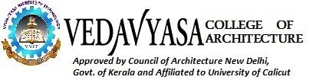

Ref: VCA/IIIC/**19-20** Date:

BONA FIDE CERTIFICATE

This is to certify that the following students are bonafide full time regular students of 5th semester B. Arch course in this institution. They are permitted to do their case study at Ladder Mankavu Greens, Mankav, Kozhikode on 05.01.2019 as a part of their academic pursuit.

List of students

|  |  |  |  |
| --- | --- | --- | --- |
| Sl. No. | Name | Admn. No. | Reg No. |
| 1 |  |  |  |
| 2 |  |  |  |
| 3 |  |  |  |
| 4 |  |  |  |

Thanking you,

Yours faithfully,

Principal

**Coordinator**

Ar. Shereef T.P

Head of the Department,

**Chair person**

Ar.Anish.C.S PRINCIPAL